

n=int(input())

for i in range(0,n):

for j in range(0,n):

print("\*",end="")

print()

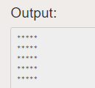

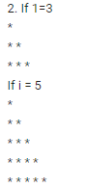

n=int(input())

for i in range(0,n+1):

for j in range(0,i):

print("\*",end="")

print()

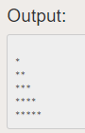

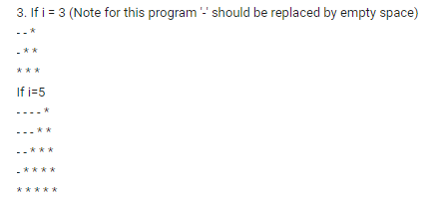

n=int(input())

for i in range(1,n+1):

for j in range(1,n+1):

if(j>n-i):

print("\*",end="")

else:

print("-",end="")

print()

